
Project Interim Report
On

Music Playlist Management System
(Using Core Java & OOP Concepts)
RU-100-01-00012
Object Oriented Programming with Java

SESSION: 2025-26

Submitted By
Priyanshu chauhan
RU-25-11042

Bachelor of Technology in Computer Science & Engineering with AI and ML in association with google

Under the Guidance of
Mr. Ashish Shivhare

SCHOOL OF COMPUTER SCIENCE AND ENGINEERING RUNGTA INTERNATIONAL SKILLS UNIVERSITY BHILAI, CG

(April 2026)

Abstract

The Music Playlist Management System is a Java-based application developed using Object-Oriented Programming (OOP) concepts. This project is designed to manage a collection of songs efficiently by allowing users to add, display, shuffle, search, and remove songs from a playlist.

In real-world scenarios, digital music players rely on playlist systems to organize and play songs seamlessly. This project simulates such functionality using basic Java programming.

The system uses concepts such as classes, objects, arrays of objects, aggregation, and randomization. Overall, it demonstrates how Java can be used to build a simple and effective playlist management system.

Introduction
The Music Playlist Management System is designed to simulate a basic music player playlist using Java. It allows users to manage songs in an organized way.
The system is built using Object-Oriented Programming principles, making it modular and easy to understand.
The project mainly consists of:
- Song Class → Stores song details (title, artist)
- Playlist Class → Manages collection of songs
- Main Class → Executes the program
This project focuses on applying OOP concepts to a real-world application.

Scope

This project is suitable for learning and demonstration purposes. It helps understand how playlist systems work.

Future improvements:

Add GUI (Java Swing/JavaFX)

Use ArrayList instead of array

Add file storage

Integrate with music APIs

Build mobile/web app

System Requirements
Hardware:
- Computer/Laptop (4GB RAM or more)
Software:
- Java JDK
- IDE (VS Code / Eclipse / IntelliJ)

Methodology

The system works step-by-step:
- User adds songs to playlist
- Songs are stored using Song class
- Playlist class manages songs using array
- User can:
  - Display songs
  - Shuffle playlist
  - Search song
  - Remove song
  - Play next song
- Output is shown in console
Flowchart

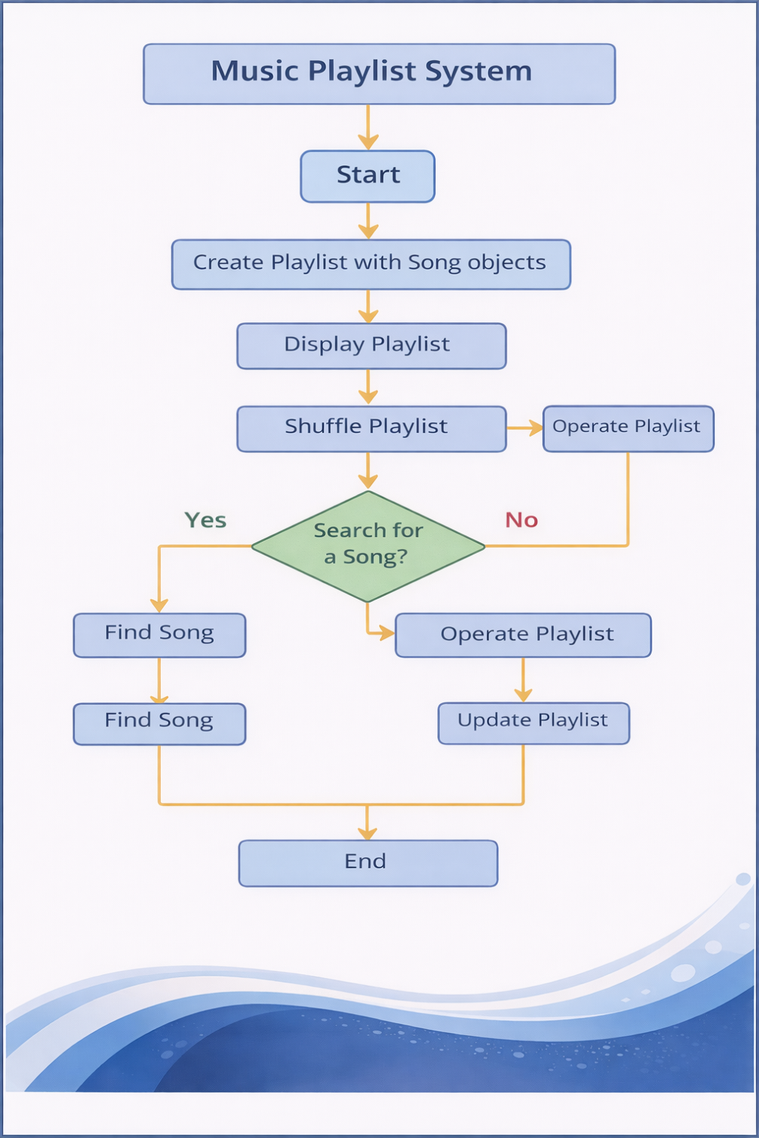

Class Diagram

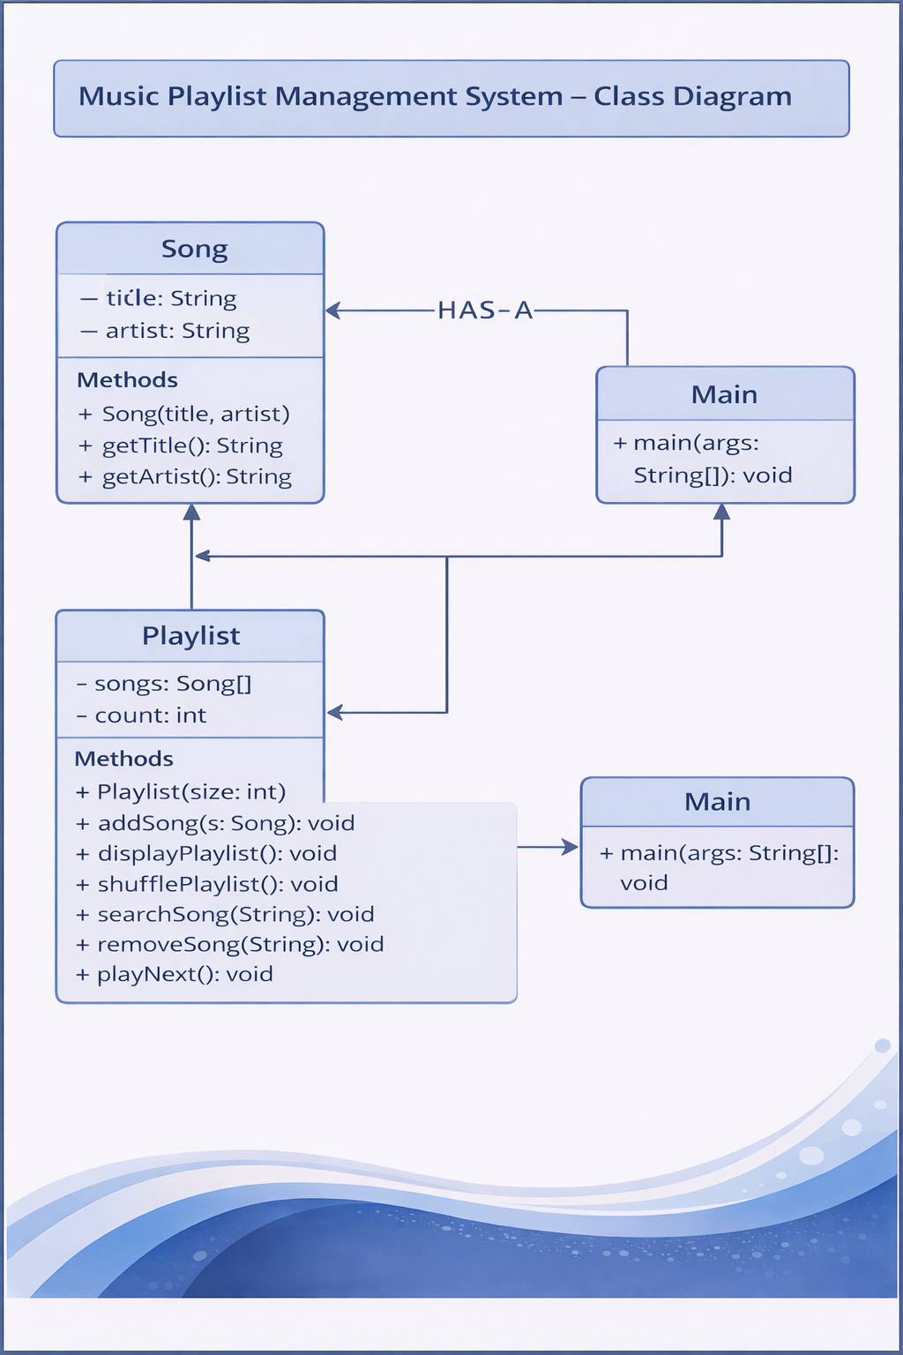

Implementation

🔹 Song Class

Stores song details using:

title

artist

Uses constructor and getter methods.

🔹 Playlist Class

Manages songs using:

Array of Song objects

Count variable

Provides methods:

addSong()

displayPlaylist()

shufflePlaylist()

searchSong()

removeSong()

playNext()

Shuffle Logic

The system uses Fisher-Yates algorithm:

Start from last element

Pick random index

Swap elements

Repeat

Learning outcome

By completing this project, students:

Understand aggregation (HAS-A relationship)

Learn arrays of objects

Implement randomization (shuffle)

Use loops effectively

Build modular design

Sample Output

Playlist:

1. Doja - Central Cee

2. Let It Happen - Tame Impala

3. Feel It - Unknown Artist

Shuffling Playlist...

Shuffled Playlist:

1. Feel It - Unknown Artist

2. Doja - Central Cee

3. Let It Happen - Tame Impala

Gantt Chart
- Planning & Structure
The project is divided into tasks such as designing, coding, and testing.

Time Management
  - Design → Day 1–2
  - Coding → Day 3–4
  - Testing → Day 5
  - Documentation → Day 6–7

Conclusion
The Music Playlist Management System successfully demonstrates the use of Object-Oriented Programming concepts such as classes, objects, aggregation, and arrays.
It provides a simple and efficient way to manage songs and simulate playlist behavior. The project can be further enhanced with advanced features like GUI and database integration.

References

- Java: The Complete Reference – Herbert Schildt
- Oracle Java Documentation
- TutorialsPoint Java Guide

